**Engineering Mechanics Objective Questions**

**UNIT-I**

1. A force P of 50 N and another force Q of unknown magnitude act at 90° to each other. They are balanced by a force of 130 N. The magnitude of Q is

(A) 60 N

(B) 80 N

(C) 100 N

(D) 120 N

Answer: Option D

1. If the resultant of two forces has the same magnitude as either of the forces, then the angle between the two forces is

(A) 30°

(B) 45°

(C) 60°

(D) 120°

Answer: Option D

1. The angle between two forces to make their resultant a minimum and maximum respectively are

(A) 0° and 90°

(B) 180° and 90°

(C) 90° and 180°

(D) 180° and 0°

Answer: Option D

1. When two forces, each equal to P, act at 90°

(A) P

(B) P√2

(C) P/√2

(D) 2P

Answer: Option B

1. The resultant of two forces P and Q is R. If Q is doubled, the new resultant is perpendicular to P. Then,

(A) P=R

(B) Q=R

(C) P=Q

(D) P=Q=R

Answer: Option B

1. Three forces which act on a rigid body to keep it in equilibrium. The forces must be coplanar and

(A) Concurrent

(B) Parallel

(C) Concurrent parallel

(D) None of these

Answer: Option A

1. Coefficient of friction depends on

(A) Nature of surfaces only

(B) Area of contact only

(C) Both (A) and (B)

(D) None of the above

Answer: Option A

1. The force acting on a point on the surface of a rigid body may be considered to act

(A) At the centre of gravity of the body

(B) On the periphery of the body

(C) On any point on the line of action of the force

(D) At any point on the surface normal to the line of action of the force

Answer: Option C

1. One Newton is equivalent to

(A) 1 kg-wt

(B) 9.81 kg-wt

(C) 981 dyne

(D) 1/9.81 kg-wt

Answer: Option D

1. Coefficient of friction depends on

(A) nature of surface only

(B) area of contact only

(C) both (a) and (b)

(D) None of the above

Answer: Option A

1. A system of coplanar forces acting on a rigid body can be reduced to

(A) One force only

(B) One couple only

(C) One force and one couple only

(D) None of the above

Answer: Option C

1. The force of friction acts in a direction _____ to the direction of motion of object.

(A) Same

(B) Opposite

(C) Perpendicular

(D) Downwards

Answer: Option B

1. The force of friction depends upon

(A) Nature of surface of contact

(B) Material of objects in contact

(C) Both ‘A’ and ‘B’

(D) None of the above

Answer: Option C

1. The body will move only when

(A) Force of friction = applied force

(B) Force of friction < applied force

(C) Force of friction > applied force

(D) All of the above

Answer: Option B

1. The ratio of the limiting force of friction (F) to the normal reaction (R) is known as

(A) Coefficient of friction

(B) Force of friction

(C) Angle of friction

(D) None of the above

Answer: Option A

1. The coefficient of friction (µ) is equal to

(A) TanΦ

(B) SinΦ

(C) CotΦ

(D) CosΦ

Where Φ = angle of friction

Answer: Option A

1. When the two surfaces in contact have a thick layer of lubricant in between them, it is known as

(A) Solid friction

(B) Rolling friction

(C) Greasy friction

(D) Film friction

Answer: Option D

1. When the two surfaces in contact have a very thin layer of lubricant in between them, it is known as

(A) Solid friction

(B) Rolling friction

(C) Greasy friction

(D) Film friction

Answer: Option D

1. The force of friction is maximum when the surface

(A) Is on the point of motion

(B) Is at rest

(C) Is moving

(D) The friction remains same at all points

Answer: Option A

1. Which motion has magnitude of static frictional force directly proportional to normal reaction?

(A) Actual motion   
(B) Impending motion    
(C) Both a. and b.   
(D) None of the above

Answer: Option B

1. Frictional force depends on ________

(A) surface area in contact   
(B) roughness of surface    
(C) both a. and b.   
(D) none of the above

Answer: Option B

1. Which formula is used to calculate angle of static friction (Φs)?

(A) tan-1 μs    
(B) sin-1 μs   
(C) cos-1 μs   
(D) none of the above

Answer: Option A

1. Moment of a force is defined as

(A) Product of force 'F' and perpendicular distance 'd' moved in direction of force

(B) Quotient of force 'F' and perpendicular distance 'd' moved in direction of force

(C) Product of force 'F' and perpendicular distance 'd' from line of action of force to pivot

(D) Quotient of force 'F' and perpendicular distance 'd' from line of action of force to pivot

Answer: Option C

1. Two types of moment of force are

(A) Clockwise and Anti-clockwise

(B) Stable and Unstable

(C) Neutral and charged

(D) Forward and backward

Answer: Option A

1. SI unit of moment of force is

(A) N m-1

(B) N m

(C) J, where J is joules

(D) W, where W is watts

Answer: Option B

1. In order to satisfy Principle of Moment for an object in equilibrium, one needs to make sure that

(A) Sum of horizontal forces = Sum of vertical forces = 0

(B) Sum of clockwise moments about pivot > Sum of anti-clockwise moments about pivot

(C) Sum of clockwise moments about pivot < Sum of anti-clockwise moments about pivot

(D) Sum of clockwise moments about pivot = Sum of anti-clockwise moments about pivot

Answer: Option D

1. Combined effect of several forces is known as

(A) net force

(B) resultant force

(C) normal force

(D) weight

Answer: Option B

1. Force applied by a lady is 2 N and moment of force is 16 Nm, distance of pivot from effort would be

(A) 32 N

(B) 8 N

(C) 14 N

(D) 18 N

Answer: Option B

1. Turning effect of force is termed as

(A) action of force

(B) action of torque

(C) unstable action of force

(D) moment of torque

Answer: Option D

1. To form a couple, force should be

(A) equal in magnitude

(B) parallel and opposite

(C) separated by distance

(D) all of above

Answer: Option D

1. Moment of force depends upon

(A) magnitude of force

(B) perpendicular distance of force from pivot

(C) both A and B

(D) axis of rotation

Answer: Option C

1. Moment of force applied on a door is 15 N m and force applied is 3.75 N, distance of handle from pivot is

(A) 11.25 m

(B) 18.75 m

(C) 4 m

(D) 45 m

Answer: Option C

1. Moment of force is 8 Nm and distance of pivot from handle is 2 N, force applied would be

(A) 4 N

(B) 10 N

(C) 6 N

(D) 16 N

Answer: Option A

1. Every object has mass and weight, but one that acts downwards is

(A) Mass

(B) Weight

(C) Both

(D) None

Answer: Option B

1. Moment of force is a/an

(A) Scalar quantity

(B) Abbrevial quantity

(C) Base quantity

(D) Vector quantity

Answer: Option D

1. Two perpendicular components are

(A) independent of each other

(B) dependent on each other

(C) anti parallel to each other

(D) parallel to each other

Answer: Option A

1. If resultant vector forms an angle of 45°, then two components are

(A) parallel to each other

(B) perpendicular to each other

(C) anti parallel to each other

(D) anti perpendicular to each other

Answer: Option B

1. Change from initial position to final position is called

(A) displacement

(B) distance

(C) speed

(D) velocity

Answer: Option A

1. At surface of Earth where air friction is negligible, objects fall with the

(A) different acceleration

(B) same velocity

(C) same acceleration

(D) same speed

Answer: Option C

1. Time rate of change of displacement is known as

(A) displacement

(B) distance

(C) speed

(D) velocity

Answer: Option D

1. F = ma, this equation is referred to as newton's

(A) second law

(B) first law

(C) third law

(D) fourth law

Answer: Option A

1. Mass of object is quantitative measure of its inertia stated law is newton's

(A) first law

(B) second law

(C) third law

(D) fourth law

Answer: Option A

1. Time rate of change of momentum of a body is equal to

(A) displacement

(B) applied force

(C) speed

(D) velocity

Answer: Option B

1. Rate of change of velocity of body is said to be

(A) displacement

(B) distance

(C) acceleration

(D) velocity

Answer: Option C

1. "Every action has an equal and opposite reaction" is Newton's

(A) first law

(B) second law

(C) third law

(D) fourth law

Answer: Option C

1. Acceleration produced in a body is the

(A) scalar quantity

(B) vector quantity

(C) physical quantity

(D) both a and b

Answer: Option B

1. Point of intersection of two coordinate axes is called

(A) mid

(B) origin

(C) circumference

(D) radius

Answer: Option B

1. A vector having 'magnitude only' is called

(A) scalar

(B) resultant

(C) unit vector

(D) temperature

Answer: Option C

1. Two forces 10 N and 20 N making an angle 30° and 60° will give a resultant force of

(A) 15 N

(B) 26 N

(C) 27 N

(D) 29 N

Answer: Option D

1. Projection of vector A in direction of x-axis is represented by angle of

(A) Cos

(B) Sin

(C) Tan

(D) both a and b

Answer: Option A

1. Position vector is vector that defines vector's

(A) angle

(B) direction

(C) magnitude

(D) position

Answer: Option D

1. Forces passing through a common point are known as _____

(A) collinear forces   
(B) co-planer forces   
(C) concurrent forces    
(D) none of the above

Answer: Option C

1. Varignon's theorem is used to find ________

(A) direction of resultant force   
(B) location of resultant force    
(C) magnitude of resultant force   
(D) nature of resultant force

Answer: Option B

1. Varingon's theorem of moments states that if a number of coplanar forces acting on a particle are in equilibrium, then

(A) Their algebraic sum is zero

(B) Their lines of action are at equal distances

(C) The algebraic sum of their moments about any point in their plane is zero

(D) The algebraic sum of their moments about any point is equal to the moment of their resultant force about the same point

Answer: Option D

1. Couple is formed due to two ______

(A) like, parallel and non-collinear forces of same magnitude   
(B) like, perpendicular and collinear forces of different magnitude   
(C) unlike, parallel and non-collinear forces of same magnitude    
(D) unlike, perpendicular and non-collinear forces of different magnitude

Answer: Option A

1. Which of the following conditions do not change the effect of couple?

(A) Shifting of couple to a new position in its plane   
(B) Shifting of couple to a parallel plane   
(C) Rotation of couple in its plane   
(D) All of the above

Answer: Option D

1. If two concurrent forces A and B acting on a point are 200 N and 300 N. What is the magnitude of resultant force, if it makes an angle of 50o with each force?

(A) 471.08 N   
(B) 455.12 N    
(C) 400.56 N   
(D) Insufficient data

Answer: Option B

1. The maximum and minimum magnitude of resultant forces is 1000 N and 500 N at point. What are the values of two forces acting on it?

(A) 500 N, 500 N   
(B) 450 N, 550 N   
(C) 300 N, 700 N   
(D) 250 N, 750 N

Answer: Option D

1. Which of the following statements is false about forces/couple?

(A) Moment of couple is free vector   
(B) Resultant and equilibrant are equal in magnitude and direction    
(C) Resultant of a couple is always zero    
(D) Parallelogram law is to be proved experimentally

Answer: Option B

1. Which of the following do not have identical dimensions?

(A) Momentum and impulse

(B) Torque and energy

(C) Torque and work

(D) Moment of a force and couple

Answer: Option D

**UNIT-II**

1. The following is in unstable equilibrium

(A) A uniform solid cone resting on a generator on a smooth horizontal plane

(B) A uniform solid cone resting on its base on a horizontal plane

(C) A solid cube resting on one edge

(D) A satellite encircling the earth

Answer: Option C

1. The member forces in a statically in determinate truss

(A) Can be obtained by graphic statics

(B) Cannot be obtained by graphic statics

(C) May be obtained by graphic statics

(D) Can be obtained by graphic statics by trial and error

Answer: Option B

1. Free body diagram is an

(A) Isolated joint with only body forces acting on it

(B) Isolated joint with internal forces acting on it

(C) Isolated joint with all the forces, internal as well as external, acting on it

(D) None of the above

Answer: Option C

1. The graphical method of determining the forces in the members of a truss is based on

(A) Method of joint

(B) Method of section

(C) Either method

(D) None of the two methods

Answer: Option A

1. If two forces are in equilibrium, then the forces must

(i) be equal in magnitude

(ii) be opposite in sense

(iii) act along the same line

(A) (i) and (ii)

(B) (i) and (iii)

(C) only (i)

(D) (i), (ii) and (iii)

Answer: Option D

1. The graphical method of determining the forces in the members of a truss is based on

(A) Method of joint

(B) Method of section

(C) either method

(D) none of the two methods

Answer: Option A

1. The member forces in a statically in determinate truss

(A) can be obtained by graphic statics

(B) cannot be obtained by graphic statics

(C) may be obtained by graphic statics

(D) can be obtained by graphic statics by trial and error

Answer: Option B

1. A cube on a smooth horizontal surface

(A) Cannot be in stable equilibrium

(B) Cannot be in neutral equilibrium

(C) Cannot be in unstable equilibrium

(D) All the above

Answer: Option D

1. The following is in unstable equilibrium

(A) A uniform solid cone resting on a generator on a smooth horizontal plane

(B) A uniform solid cone resting on its base on a horizontal plane

(C) A solid cube resting on one edge

(D) All the above

Answer: Option C

1. Which of the following represents the state of neutral equilibrium?

(A) A smooth cylinder lying on a curved surface

(B) A smooth cylinder lying on a convex surface

(C) A cube resting on one edge

(D) None of the above

Answer: Option D

1. When an object is tilted slightly and it topples over, state is termed

(A) Unstable equilibrium

(B) Stable equilibrium

(C) Neutral equilibrium

(D) Stability

Answer: Option A

1. Correct condition for state of equilibrium in principle of moment is

(A) distance between two objects in beam balance should be same

(B) resultant force should be zero

(C) weight of both objects on beam balance should be same

(D) tension should be equal on both sides

Answer: Option B

1. Object is in equilibrium if resultant force acting on it is

(A) increasing

(B) decreasing

(C) zero

(D) becomes constant

Answer: Option C

1. For a non-concurrent force system to be in equilibrium

(A) Only the closure of force polygon is sufficient

(B) Only the closure of funicular polygon is sufficient

(C) Both force polygon and funicular polygon must close

(D) None of the above

Answer: Option C

1. The force polygon representing a set of forces in equilibrium is a

(A) Triangle

(B) Open polygon

(C) Closed polygon

(D) Parallelogram

Answer: Option C

1. Force polygon method is applicable for

(A) Any coplanar force system

(B) A system of parallel forces only

(C) Concurrent coplanar force system

(D) Non-concurrent coplanar force system

Answer: Option C

1. The force polygon representing a set of forces in equilibrium is a

(A) Triangle

(B) Open polygon

(C) Closed polygon

(D) Parallelogram

Answer: Option C

1. If the given forces P1, P2, P3 and P4 are such that the force polygon does not close, then the system will

(A) be in equilibrium

(B) always reduce to a resultant force

(C) always reduce to a couple

(D) both (a) and (c)

Answer: Option B

1. The condition of equilibrium for any system of forces in a plane is

(A) that polygon of forces must close

(B) that resultant couple must be zero

(C) both (a) and (b)

(D) none of the above

Answer: Option C

1. Which theory states that “if a body is in equilibrium under the action of three coplanar and concurrent forces, each of the forces is proportional to the sine of the angle between the other two”

(A) Triangle Law of Forces

(B) Lami’s Theorem

(C) Parallelogram Law of Forces

(D) Polygon Law of Forces

Answer: Option B

1. Which of the following conditions should be satisfied for co-planer concurrent forces to be in equilibrium?

(A) Σ Fx = Σ Fy = 0    
(B) Σ M = 0   
(C) Both a. and b.   
(D) None of the above

Answer: Option A

1. According to Lami's theorem, a body is in equilibrium condition if each force among three are proportional to sine angle between other two.

(A) coplanar, collinear forces   
(B) collinear, non-concurrent forces   
(C) coplanar, non-concurrent forces   
(D) coplanar, concurrent forces

Answer: Option D

1. Which axial force is determined while analyzing a truss?

(A) compressive force

(B) tensile force

(C) both a. and b.

(D) none of the above

Answer: Option C

1. Which is the correct statement about law of polygon of forces?

(A) If any number of forces acting at a point can be represented by the sides of a polygon taken in order, then the forces are in equilibrium

(B) If any number of forces acting at a point can be represented in direction and magnitude by the sides of a polygon, then the forces are in equilibrium

(C) If a polygon representing forces acting at a point is closed then forces are in equilibrium

(D) If any number of forces acting at a point can be represented in direction and magnitude by the sides of a polygon taken in order, then the forces are in equilibrium

Answer: Option D

1. The bellow figure shows the three coplanar forces P, Q and R acting at a point O. If these forces are in equilibrium, then

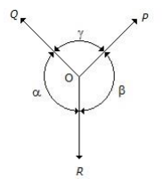

(A) P/sin β = Q/sin α = R/sin ɣ

(B) P/sin α = Q/sin β = R/sin ɣ

(C) P/sin ɣ = Q/sin α = R/sin β

(D) P/sin α = Q/sin ɣ = R/sin β

Answer: Option B

1. According to law of triangle of forces

(A) Three forces acting at a point will be in equilibrium

(B) Three forces acting at a point can be represented by a triangle, each side being proportional to force

(C) If three forces acting upon a particle are represented in magnitude and direction by the sides of a triangle, taken in order, they will be in equilibrium

(D) If three forces acting at a point are in equilibrium, each force is proportional to the sine of the angle between the other two

Answer: Option C

1. If three forces acting in different planes can be represented by a triangle, these will be in

(A) Non-equilibrium

(B) Partial equilibrium

(C) Full equilibrium

(D) Unpredictable

Answer: Option A

1. In order to determine the effects of a force, acting on a body, we must know

(A) Magnitude of the force

(B) Line of action of the force

(C) Nature of the force i.e. whether the force is push or pull

(D) All of the above

Answer: Option D

1. According to Lami’s theorem

(A) The three forces must be equal

(B) The three forces must be at 120° to each other

(C) The three forces must be in equilibrium

(D) If the three forces acting at a point are in equilibrium, then each force is proportional to the sine of the angle between the other two

Answer: Option D

1. Which of the following are vector quantities?

(A) Linear displacement

(B) Linear acceleration

(C) Linear velocity

(D) All of the above

Answer: Option D

1. According to the law of moments, if a number of coplanar forces acting on a particle are in equilibrium, then

(A) Their algebraic sum is zero

(B) Their lines of action are at equal distances

(C) The algebraic sum of their moments about any point in their plane is zero

(D) The algebraic sum of their moments about any point is equal to the moment of their resultant force about the same point

Answer: Option C

1. If a number of forces are acting at a point, their resultant is given by

(A) (∑V)2 + (∑H)2 ]

(B) √[(∑V)2 + (∑H)2 ]

(C) (∑V)2 +(∑H)2 +2(∑V)(∑H)

(D) √[(∑V)2 +(∑H)2 +2(∑V)(∑H)]

Answer: Option B

1. Assume the three force vectors intersect at a single point.

F1 = 4i + 2j + 5k

F2 = –2i + 7j – 3k

F3 = 2i – j + 6k

What is the magnitude of the resultant force vector, R?

(A) 14

(B) 12

(C) 13

(D) 15

Answer: Option B

1. Given the 3-dimensional vectors:

A = i(xy) + j(2yz) + k(3zx)

B = i(yz) + j(2zx) + k(xy)

Determine the magnitude of the vector sum |A + B| at coordinates (3,2,1).

(A) 32.92

(B) 29.92

(C) 27.20

(D) 24.73

Answer: Option B

1. At what angle does the force F = 6.23i – 2.38j +4.92 kN makes with the x-axis?

(A) 39.2 deg

(B) 40.2 deg

(C) 41.3 deg

(D) 42.2 deg

Answer: Option C

1. Assume the three force vectors intersect at a single point.

F1 = i + 3j + 4k

F2 = 2i + 7j – k

F3 = -i + 4j + 2k

What is the magnitude of the resultant force vector, R?

(A) 15

(B) 13.23

(C) 14.73

(D) 16.16

Answer: Option A

1. A particle is in equilibrium if the resultant of all forces acting on the particle is equal to zero.

(A) resolution of the vector

(B) addition of the vector

(C) equilibrium equation for a particle

(D) particle

Answer: Option C

1. In a rectangular coordinate system, the equilibrium equations can be represented by three scalar equations.

(A) equilibrium equation in component form

(B) free body diagram

(C) string or cable

(D) linear spring

Answer: Option A

1. A mechanical device that can only transmit a tensile force along itself.

(A) equilibrium equation in component form

(B) free body diagram

(C) string or cable

(D) linear spring

Answer: Option A

1. The tension in the cable is the same on both sides of the pulley.

(A) frictionless pulley

(B) static equilibrium for a rigid body

(C) newton’s 3rd law

(D) composite bodies and external source

Answer: Option A

1. Each force or couple putted on a free diagram represents a model of how a body is affected by its surroundings.

(A) a two force member

(B) a three force member

(C) forces and couples of a free body

(D) truss

Answer: Option C

1. It is a structure made of two force members all pin is connected to each other.

(A) a two force member

(B) a three force member

(C) forces and couples of a free body

(D) truss

Answer: Option D

1. A body which has forces applied onto it at only two points and no couples applied onto it at all.

(A) a two force member

(B) a three force member

(C) forces and couples of a free body

(D) truss

Answer: Option A

1. A body which has forces applied onto it at only three points and no couples applied onto it at all.

(A) a two force member

(B) a three force member

(C) forces and couples of a free body

(D) truss

Answer: Option B

1. This method uses the free body diagram of joints in the structure to determine the forces in each member.

(A) method of joints

(B) the method of sections

(C) zero force member

(D) a redundant joint

Answer: Option A

1. This method uses free body diagrams of sections of the truss to obtain unknown forces.

(A) method of joints

(B) the method of sections

(C) zero force member

(D) a redundant joint

Answer: Option B

1. Some members in the truss which cannot carry load.

(A) method of joints

(B) the method of sections

(C) zero force member

(D) a redundant joint

Answer: Option C

1. A system of forces acting on a body which has no resultant.

(A) free body diagram

(B) equilibrium

(C) coplanar

(D) force

Answer: Option B

1. 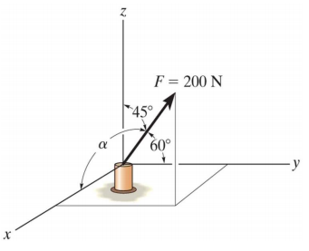A force F of 200 N is acting on a bolt as shown in below figure. Express the force F in terms of Cartesian vector.

(A) F =[10 i + 10 j + 141.4k] N

(B) F =[50 i + 100 j + 441.4k] N

(C) F =[70 i + 10 j + 144.4k] N

(D) F =[100 i + 100 j + 141.4k] N

Answer: Option D

1. Is a sketch of a body completely isolated or free from all other bodies?

(A) free body diagram

(B) equilibrium

(C) coplanar

(D) force

Answer: Option A

1. The external effect of a force in a rigid body is the same for all points along its line of action.

(A) principle of transmissibility of a force

(B) axioms of mechanics

(C) characteristics of force

(D) scalar and vector quantities

Answer: Option A

1. Two forces of F1 and F2 are acting on an eye bolt as shown in figure. Find the resultant force vector of the system of forces and its magnitude. Also find out the coordinate angles of the forces.

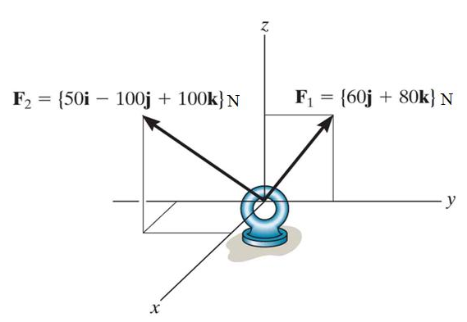(A) 171 N

(B) 181 N

(C) 191 N

(D) 161 N

Answer: Option C

1. It is an additional force that exactly balances a resultant force.

(A) reactant

(B) equilibrant

(C) buoyant

(D) reverse effective force

Answer: Option B

1. The equilibrant of the forces 10 N at 10° and 15 N at 100° is

(A)18 N at 246°

(B)18 N at 66°

(C) 25 N at -114°

(D) 25 N at 66°

Answer: Option A

1. A signal pendant weighing 80 N is supported by two cables as shown in below figure. Determine the tensions T1 and T2 in the cables.

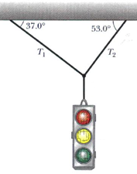

(A) T1 = 68.15 N, T2 = 53.90 N

(B) T1 = 45.05 N, T2 = 60.00 N

(C) T1 = 38.15 N, T2 = 53.90 N

(D) T1 = 48.15 N, T2 = 63.90 N

Answer: Option D

1. The magnitude of the resultant of the vectors shown in figure is

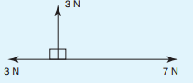(A) 5 N

(B) 13 N

(C) 1 N

(D) 63 N

Answer: Option A

1. Which of the following statements is false?

(A) There is always a resultant vector required to close a vector diagram representing a system of coplanar forces acting at a point, which are not in equilibrium

(B) A vector quantity has both magnitude and direction

(C) A vector diagram representing a system of coplanar forces acting at a point when in equilibrium does not close

(D) Concurrent forces are those which act at the same time at the same point

Answer: Option C

1. Which of the following statements is false?

(A) The resultant of coplanar forces of 1 N, 2 N and 3 N acting at a point can be 4 N

(B) The resultant of forces of 6 N and 3 N acting in the same line of action but opposite in sense is 3 N

(C) The resultant of forces of 6 N and 3 N acting in the same sense and having the same line of action is 9 N

(D) The resultant of coplanar forces of 4 N at 0◦, 3 N at 90◦ and 8 N at 180◦ is 15 N

Answer: Option D

1. Which notation is considered for the representation of forces in graphical method

(A) Bow’s notation

(B) Dow’s notation

(C) Kow’s notation

(D) Fow’s notation

Answer: Option A

1. Polygon law of forces applicable for

(A) only two forces

(B) more than two forces

(C) both (A) and (B)

(D) none of the above

Answer: Option B

**Unit-III**

1. Point where whole weight of body acts vertically is called
2. centre of mass
3. mid-point
4. centre of gravity
5. none of above

**Ans: C**

1. It is a point within an object from which the force of gravity appears to act
2. center of gravity
3. centroid
4. center of mass
5. all of the above are correct

**Ans: A**

1. The centre of gravity and centroids are
2. Same
3. Different
4. Equal and opposite
5. None of these

**Ans: B**

1. It is a point where whole area of the figure is assumed to be concentrated
2. center of gravity
3. centroid
4. center of mass
5. all of the above are correct

**Ans: B**

1. A body has only ___ centre of gravity.
2. One
3. Two
4. Three
5. Can’t be said

**Ans: A**

1. Center of gravity of an object does not depend on it's
2. volume
3. mass
4. density
5. shape

**Ans: D**

1. Which of the following statements is false?
2. The centroid of a lamina is at its point of balance
3. The centroid of a circular lamina is at its centre
4. The centroid of a rectangular lamina is at the point of intersection of its two sides
5. The centroid of a thin uniform rod is halfway along the rod

**Ans: C**

1. The unit of coordinates of centre of gravity from reference axis can be
2. Kg
3. cm
4. cm2
5. gm

**Ans: B**

1. The centroid of a circular arc of radius ‘r’ and circular disc of radius ‘r’ lies at distance of ______ & ______ from their geometrical centres respectively.
2. r, r
3. r, r/2
4. r/2, r
5. 0, 0

**Ans: D**

1. Centroid of an equilateral triangle with each side ‘a’ is ___________ from any of the three sides

$\frac{a√3}{2}$

$\frac{a√2}{3}$

$\frac{a}{2√3}$

$\frac{a}{3√2}$

**Ans: C**

1. The centroid of a triangle of height ‘h’ is located at a distance of _______ from the base

$\frac{h}{2}$

$\frac{2h}{3}$

$\frac{h}{3}$

$h$

**Ans: C**

1. The centroid of a triangle of height ‘h’ is located at a distance of _______ from its apex.

$\frac{h}{2}$

$\frac{2h}{3}$

$\frac{h}{3}$

$h$

**Ans: B**

1. Moment of total area about the centroidal axis is,
2. Twice the area
3. Three times the area
4. Zero
5. None of these

**Ans: C**

1. If a given figure is symmetrical about vertical Y-Y axis, the centroid lies on
2. X-X axis
3. Y-Y axis
4. Axis passing through base of the figure
5. Axis passing through top of the figure

**Ans: B**

1. The centroid of a semi-circle of radius R from its diametric axis is

$\frac{3R}{4π}$

$\frac{3R}{8π}$

$\frac{4R}{π}$

$\frac{4R}{3π}$

**Ans: D**

1. The centroid of a hemisphere of radius ‘r’ lies at a distance of _____ from the top most portion of the hemisphere

$\frac{8r}{3}$

$\frac{3r}{8}$

$\frac{5r}{3}$

$\frac{5r}{8}$

**Ans: D**

1. An axis over which half of the plane figure is just mirror image of the other half is,
2. Bottom most axis of the figure
3. Axis of symmetry
4. Unsymmetrical axis
5. None of these

**Ans: B**

1. A T- section is symmetric to
2. Horizontal axis
3. Vertical axis
4. Both horizontal and vertical axis
5. None of these

**Ans: B**

1. A channel section is symmetric to
2. Horizontal axis
3. Vertical axis
4. Both horizontal and vertical axis
5. None of these

**Ans: A**

1. The centre of gravity of hemisphere lies at a distance of ________from its base measured along the vertical radius.

$\frac{8}{3r}$

$\frac{3}{8r}$

$\frac{8r}{3}$

$\frac{3r}{8}$

**Ans: D**

1. The centre of gravity of a right circular solid cone of diameter ‘d’ and height ‘h’ lies at a distance of _________ from the base measured along the vertical radius.

$\frac{h}{2}$

$\frac{h}{3}$

$\frac{h}{4}$

$\frac{h}{6}$

**Ans: C**

1. The centre of gravity of a hollow cone of diameter ‘d’ and height ‘h’ lies at a distance of ______ from the base measured along the vertical radius.

$\frac{h}{2}$

$\frac{h}{3}$

$\frac{h}{4}$

$\frac{h}{6}$

**Ans: B**

1. Find the centroid of the given figure

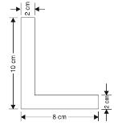

1. $\overline{x}$ = 2.5 cm & $\overline{y}$ = 3.5 cm
2. $\overline{x}$ = 3.5 cm & $\overline{y}$ = 3.5 cm
3. $\overline{x}$ = 2.5 cm & $\overline{y}$ = 2.5 cm
4. $\overline{x}$ = 3.5 cm & $\overline{y}$ = 2.5 cm

**Ans: A**

1. A L Section is symmetric to
2. Horizontal axis
3. Vertical axis
4. Both horizontal and vertical axis
5. None of these

**Ans: D**

1. Locate the centroid of the exparabolic segment of area.

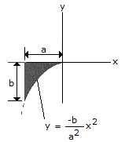

1. $\overline{x}$ = -4a/5, $\overline{y}$  = -b/4
2. $\overline{x}$ = -3a/4, $\overline{y}$ = -3b/10
3. $\overline{x}$ = -2a/3, $\overline{y}$ = -b/3
4. $\overline{x}$ = -5a/7, $\overline{y}$   = -3b/8

**Ans: B**

1. Which of the following laminas do not have centroid at its geometrical centre?
2. Circle
3. Equilateral triangle
4. Right angled triangle
5. None of the above

**Answer: C**

1. If a material has no uniform density throughout the body, then the position of centroid and center of mass are ________.
2. identical
3. not identical
4. independent upon the density
5. unpredictable

**ANSWER: B**

1. centroid of trapezium of height ‘h’ and parallel sides ‘a’ and ‘b’ measured from base ‘b’ is at a distance of

$\frac{h}{2}\left(\frac{b + 2a}{a+b}\right)$

$\frac{h}{2}\left(\frac{b - 2a}{a - b}\right)$

$\frac{h}{3}\left(\frac{b + 2a}{a+b}\right)$

$\frac{h}{3}\left(\frac{b - 2a}{a-b}\right)$

**Ans: C**

1. What is the centroidal distance along the line of symmetry XO for the quarter circle shown below? (Where D= 4r/3π).

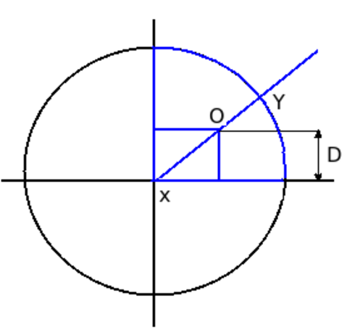

1. √2 (D)
2. √2 (D2)

**ANSWER: C**

1. If an area has one axis of symmetry the centroid will
2. lie somewhere along the axis symmetry
3. lie anywhere on the area
4. lie in the midpoint of the axis of symmetry
5. not lie on the axis of symmetry

**ANSWER: A**

1. What is the angle made by side of a square lamina, if it is freely suspended from a corner with the horizontal?
2. 0o
3. 45o
4. 90o
5. 180o

**ANSWER: B**

1. What is the C.G of an isosceles triangle of base 20 cm and side 40?
2. 12.90 cm from the base
3. 13.28 cm from the base
4. 19.36 cm from the base
5. 38.72 cm from the base

**ANSWER: A**

1. What is the centroidal distance of an equilateral triangle of side 2 m?
2. 0.866 m from the base
3. 0.769 m from the base
4. 1.000 m from the base
5. 0.577 m from the base

**ANSWER: D**

1. The x and y coordinate of centroid of a cylinder of radius ‘r’ and height ‘h’ from the centre of the base of cylinder will be
2. r, h
3. 0, h/2
4. r/2, 0
5. r/2, h/2

**Ans: B**

1. What is the distance of centroid with respect to XX and YY axes as shown in diagram below?

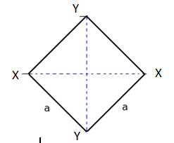

1. a /√3
2. a /√2
3. a /√18
4. 0

**ANSWER: D**

1. What is the centroid of a isosceles triangle with base ‘q’ and side ‘p’

$\frac{\sqrt{{4P}^{2}- q^{2}}}{6}$

$\frac{\sqrt{{4P}^{2}+ q^{2}}}{6}$

$\frac{\sqrt{{4P}^{2}- q^{2}}}{8}$

$\frac{\sqrt{{4P}^{2}+ q^{2}}}{8}$

**Ans: A**

1. Locate the centroid of the shaded area.

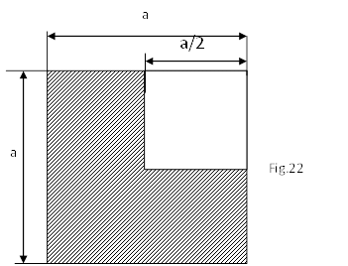

1. $\overline{x}$ = a, $\overline{y}$ = a
2. $\overline{x}$ = $\frac{a}{2}$, $\overline{y}$  = $\frac{a}{2}$
3. $\overline{x}$ = $\frac{a}{4}$, $\overline{y}$  = $\frac{a}{4}$
4. $\overline{x}$ = $\frac{5a}{12}$, $\overline{y}$  = $\frac{5a}{12}$

**ANSWER: D**

1. Determine the distance $\overline{y}$  to the centroidal axis $\overline{XX}$  of the beam's cross-sectional area.

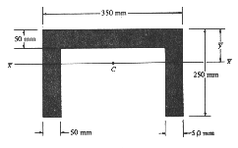

1. $\overline{y}$ = 112.3 mm
2. $\overline{y}$ = 125.0 mm
3. $\overline{y}$ = 91.7 mm
4. $\overline{y}$ = 100.0 mm

**Ans: C**

1. Locate the center of gravity of the volume generated by revolving the shaded area about the z axis. The material is homogeneous.

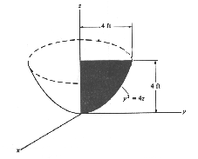

1. $\overline{y}$ = 2.67 ft
2. $\overline{y}$ = 2.50 ft
3. $\overline{y}$ = 3.00 ft
4. $\overline{y}$ = 2.80 ft

**Ans: A**

1. A square sheet of side 1m has a square of one quarter of the original area cut from the corner as shown in the figure. Find out the centroid of the remaining portion of the sheet.

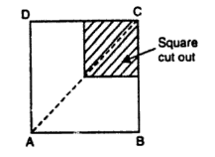

1. Distance of C.G is $\frac{5}{12}m$ from AB
2. Distance of C.G is $\frac{5}{12}m$ from AD
3. Both a & b
4. None of these

**Ans: C**

1. From a circular plate of diameter 100 mm a circular hole of 50 mm is cut as shown in the figure. Find out the centroid of the remaining portion of the sheet measured from A.

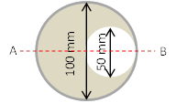

1. 50 mm
2. 47.1mm
3. 41.7 mm
4. 0 mm

**Ans: C**

1. ABCD is a square piece of paper of side 10 cm and E & F are mid points of AB and AD. Find the centroid of the portion left when triangular portion is cut as from the paper shown in the figure.

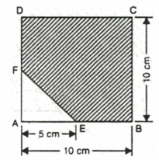

1. $\overline{x}$ = 5.476 cm & $\overline{y}$ = 3.5 cm
2. $\overline{x}$ = 3.5 cm & $\overline{y}$ = 5.476 cm
3. $\overline{x}$ = 5.476 cm & $\overline{y}$ = 5.476 cm
4. $\overline{x}$ = 3.5 cm & $\overline{y}$ = 3.5 cm

**Ans: C**

1. A semi-circle of diameter 100 mm is drawn on a sheet of paper. A triangle with diameter of the semi-circle as the base is cut-out of the semi-circular paper as shown in the figure. Find the centroid of the remaining portion.

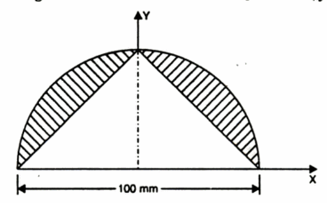

1. $\overline{x}$ = 0 cm & $\overline{y}$ = 21.2 cm
2. $\overline{x}$ = 29.2 cm & $\overline{y}$ = 0 cm
3. $\overline{x}$ = 0 cm & $\overline{y}$ = 29.2 cm
4. $\overline{x}$ = 29.2 cm & $\overline{y}$ = 21.2 cm

**Ans: C**

1. Pappus theorem can be used to find
2. Area generated by rotating a plane curve
3. Volume generated by rotating a plane area
4. Volume generated by rotating a plane curve
5. Both a & b

**Ans: D**

1. Find the x and y coordinate of the centroid of the figure generated by rotating the semi-circular, area as given in the figure, about the horizontal axis.

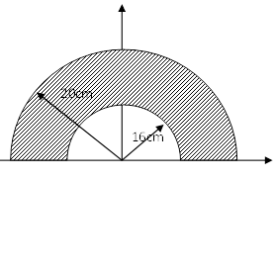

1. $\overline{x}$ = 0 cm & $\overline{y}$ = 11.5 cm
2. $\overline{x}$ = 11.5 cm & $\overline{y}$ = 0 cm
3. $\overline{x}$ = 0 cm & $\overline{y}$ = 9.07 cm
4. $\overline{x}$ = 0 cm & $\overline{y}$ = 0 cm

**Ans: D**

1. The composite figure given below can be considered to be a minimum combination of how many simple figures?

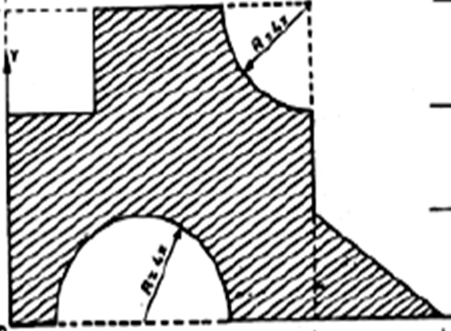

1. 4
2. 6
3. 5
4. 3

**Ans: C**

1. The general expression of centroid of any plane figure can be given by,
2. $\overline{x }= \frac{Σa}{Σax}$& $\overline{y }= \frac{Σa}{Σay}$
3. $\overline{x }= \frac{Σax}{Σx}$& $\overline{y }= \frac{Σay}{Σy}$
4. $\overline{x }= \frac{Σax}{Σa}$& $\overline{y }= \frac{Σay}{Σa}$
5. $\overline{x }= \frac{Σx}{Σax}$& $\overline{y }= \frac{Σy}{Σay}$

**Ans: C**

1. Determine the $\overline{y}$ of the given figure from the base of the section,

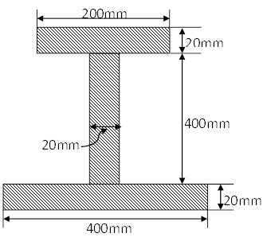

1. $\overline{y}$ = 86 mm
2. $\overline{y}$ = 187 mm
3. $\overline{y}$ = 0 mm
4. $\overline{y}$ = 178 mm

**Ans: D**

1. Locate the centroid of a quarter circle of radius ‘r’ from its radial axes,

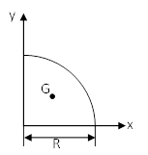

1. $\overline{x}$ = 0 & $\overline{y}$ = 0
2. $\overline{x}$ = $\frac{4R}{3π}$& $\overline{y}$ = 0
3. $\overline{x}$ = 0 & $\overline{y}$ = $\frac{4R}{3π}$
4. $\overline{x}$ = $\frac{4R}{3π}$& $\overline{y}$ = $\frac{4R}{3π}$

**Ans: D**

1. What is the surface area of conical surface of height ‘L’ as given in the figure according to Pappu’s theorem?

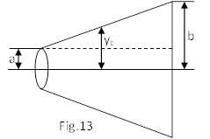

1. 2π(a+b)L
2. π(a+b)L
3. π(a+b)/L
4. None of these

**Ans: C**

1. A sphere and torus can be formed by rotating a ______ & _____ respectively about any non-intersecting axis.
2. Circle & semicircle
3. Circle & circle
4. Semicircle & circle
5. None of these

**Ans: C**

1. The surface area generated by rotating a curve can be calculated by,
2. Varignon’s theorem
3. Lami’s theorem
4. Pappus theorem – I
5. Pappus theorem - II

**Ans: C**

1. The volume generated by rotating a plane area can be calculated by,
2. Varignon’s theorem
3. Lami’s theorem
4. Pappus theorem – I
5. Pappus theorem - II

**Ans: D**

1. Centre of gravity of any solid body of volume v, mass m and surface area ‘a’ with uniform density ‘ρ’ can be given by,
2. $\overline{x }= \frac{Σax}{Σa}$& $\overline{y }= \frac{Σay}{Σa}$
3. $\overline{x }= \frac{Σvx}{Σv}$& $\overline{y }= \frac{Σvy}{Σv}$
4. $\overline{x }= \frac{Σmx}{Σm}$& $\overline{y }= \frac{Σmy}{Σm}$
5. Both b and c

**Ans: D**

1. Find out the centroid of the given composite area with respect to given x and y axes is given by

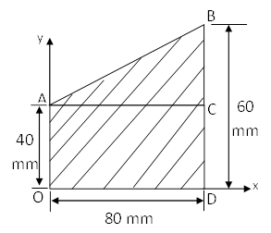

1. $\overline{x}$ = 40 mm & $\overline{y}$ = 18 mm
2. $\overline{x}$ = 42.67 mm & $\overline{y}$ = 25.33 mm
3. $\overline{x}$ = 25.33 mm & $\overline{y}$ = 42.67 mm
4. $\overline{x}$ = 42.67 mm & $\overline{y}$ = 36 mm

**Ans: B**

1. In a circular sector of radius ‘r’ subtending an angle ‘2α, at the centre, what is the distance of centroid from the centre along the radial axis?
$\frac{r\sin{α}}{α}$

$\frac{2r\sin{α}}{3α}$

$\frac{4r}{3π}$

2. None of these

**Ans: B**

1. The centroid of the given T section with reference to the given axes is,

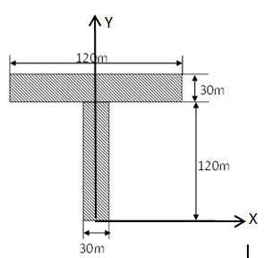

1. $\overline{x}$ = 0 cm & $\overline{y}$ = 97.5 cm
2. $\overline{x}$ = 60 m & $\overline{y}$ = 97.5 m
3. $\overline{x}$ = 0 m & $\overline{y}$ = 97.5 m
4. None of these

**Ans: C**

1. What is the distance of centroid of a circular arc or radius ‘r’ and ‘2α’ being the angle made by the arc at the centre if measured along the radial axis?
$\frac{r\sin{α}}{α}$

$\frac{2r\sin{α}}{3α}$

$\frac{4r}{3π}$

2. None of these

**Ans: A**

1. A circular sector of angle 60ο is cut from the circle of radius ‘r’ as shown in the figure. Determine the centroid along its axis of symmetry from point C

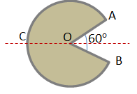

$r$

$\frac{r}{2}$

$r – \frac{4r}{3π}$

$r – \frac{2r}{5π}$

Ans: D

1. A right circular cone of 30 mm diameter and 60 mm height is cut from the bottom portion of a cylinder of 50 mm diameter at 120 mm height. Find the position of C.G of the body from its base.
2. 60 mm
3. 57.7 mm
4. 60.7 mm
5. None of these

Ans: C